PYTHON CREDIT RISK ANALYSIS

2.1 Data Loading & Inspection
2.2 Target Variable & Default Rate
2.3 Univariate Analysis
2.4 Bivariate Analysis
2.5 Credit-Risk EDA
2.6 Feature Engineering
2.7 Feature Selection
2.8 Logistic Regression
2.9 Gradient Boosting
2.10 Model Evaluation
2.11 Credit Risk Scoring
2.12 Business Recommendations

BIVARIATE ANALYSIS IN PYTHON.
-- Bivariate analysis in python is the equivalent of comparing/getting the relationship between two variables/columns in SQL using aggregates, order by and group by
-- In ML, this is usually between a TARGET VARIABLE and another variable, mostly a CATEGORICAL VARIABLE.

ONE VERY IMPORTANT MODELING ISSUE
-- There are some columns in your dataset that we should not use as application-time predictors.
-- For example: days_overdue, late_payment_count_current,repayment_ratio, loan_status. These describe what happened during/after repayment.
-- If we're building a model that predicts whether someone will default when they apply for a loan, using these variables would create data leakage.
-- For example: If we tell the model that a borrower was already 60 days overdue, the model isn't really predicting future default — it's being given information about the outcome.
-- We'll therefore separate:
Application-time information
-- Things the lender could know when assessing the application:
- income
- savings
- existing debt
- loan amount
- loan term
- proposed monthly repayment
- employment
- county
- previous loans
- previous defaults
- previous late payments
- mobile-money history
- utility payment consistency
- income consistency

Post-loan information
-- Things that happen after the loan is issued:
- days overdue
- current late payments
- repayment ratio
- loan status

NUMBER OF DEFAULTS BY LOAN PRODUCT
-- Which loan products have higher or lower default rates?
-- Shows whether the type/purpose of loan is associated with different repayment performance.
-- Some products may have higher default because of their borrower profile, loan purpose, terms, or repayment structure.
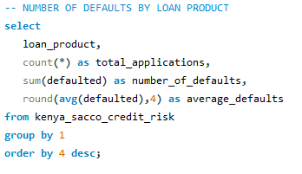
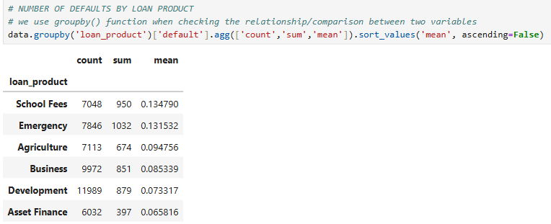
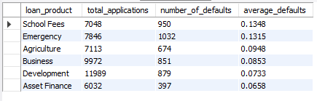

DEFAULT RATE BY LOAN PRODUCT
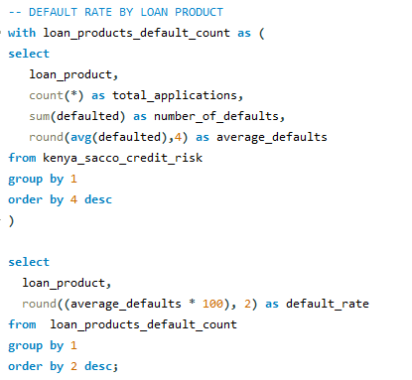
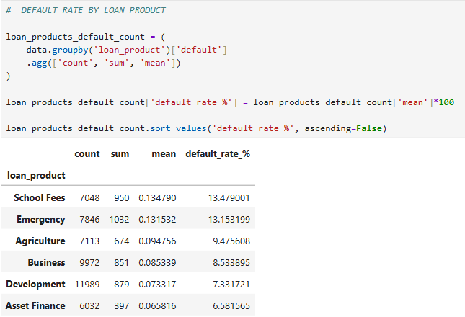
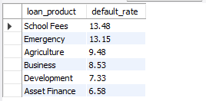

NUMBER OF DEFAULTS BY EMPLOYMENT TYPE
-- Does default risk differ between employed, self-employed, casual, or unemployed borrowers?
-- Shows whether borrowers with different income/employment stability have different default rates.
-- More stable employment may be associated with lower default, while less predictable income may be associated with higher default.
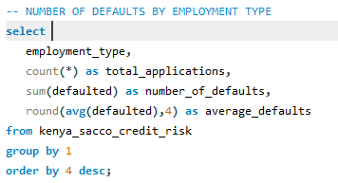
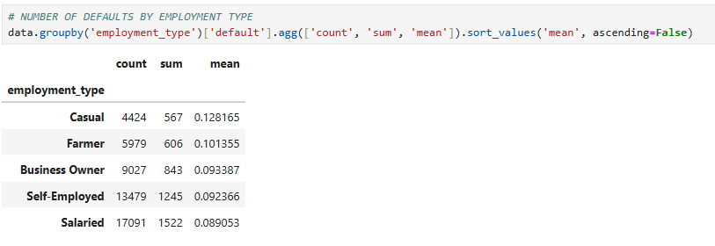
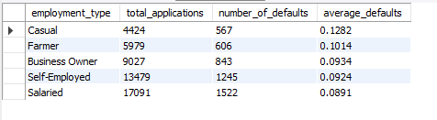

DEFAULT RATE BY EMPLOYMENT TYPE
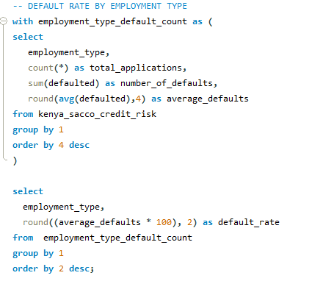
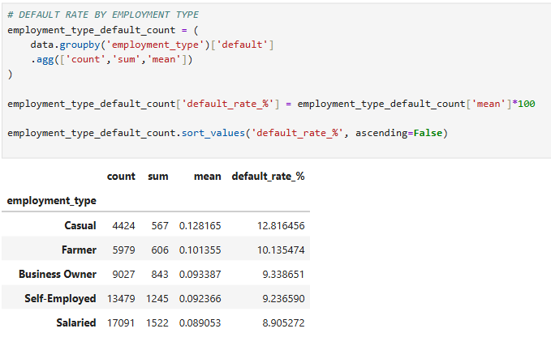
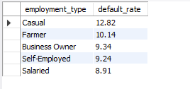
-- We want to know whether observed default rates differ between employment categories.
-- A good interpretation would be: Default rates vary across employment categories, indicating that employment status may contain useful information for credit-risk segmentation. However, employment type should be evaluated together with income stability, debt obligations, repayment history and other borrower characteristics.

LOAN AMOUNT VS DEFAULT
-- Are larger loans associated with greater default risk?
-- Shows whether default rates change as the amount borrowed increases.
-- Larger loans can create greater repayment obligations and may be associated with higher default, particularly when the loan is large relative to income.
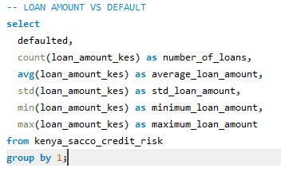
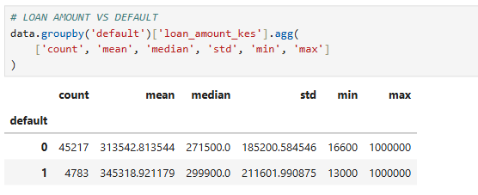

DEFAULT COUNT BY COUNTY
-- Does default performance vary across counties?
-- Identifies geographic differences in default rates.
-- Some counties may show higher/lower observed default rates, potentially reflecting differences in economic conditions, borrower profiles, or portfolio composition.
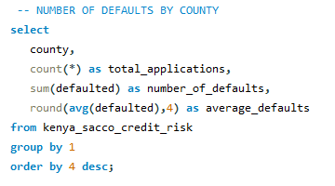
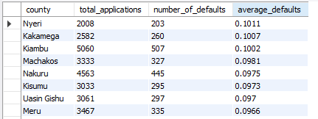
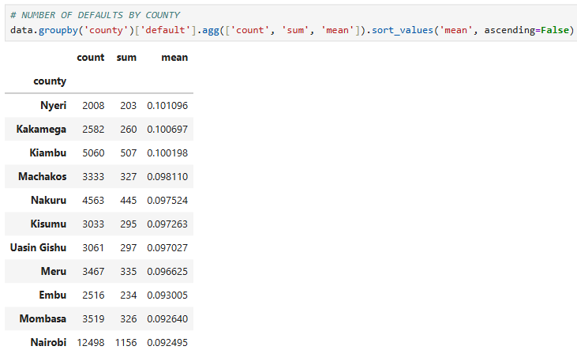

DEFAULT RATE BY COUNTY

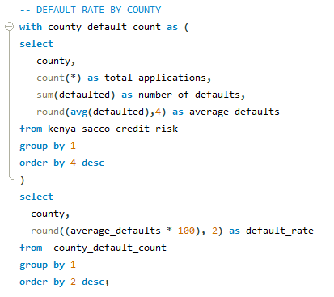

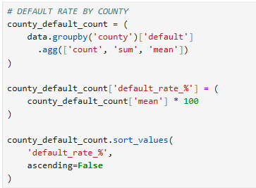
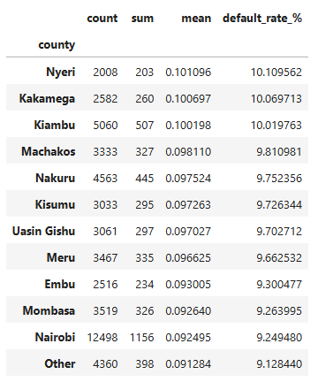

INCOME VS DEFAULT
-- Are borrowers with higher incomes less likely to default?
-- Examines whether repayment performance changes as borrower income increases.
-- Higher income may be associated with lower default because the borrower has greater repayment capacity.
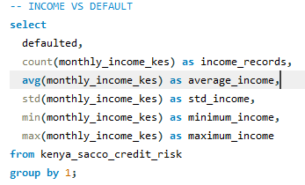
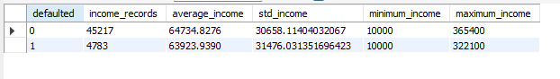
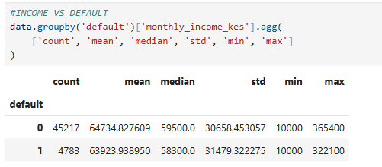

PREVIOUS DEFAULTS VS CURRENT DEFAULT
-- Are borrowers who previously defaulted more likely to default again?
-- Measures whether past default history is associated with future default.
-- A history of previous defaults would generally be expected to correspond with higher observed default risk.
-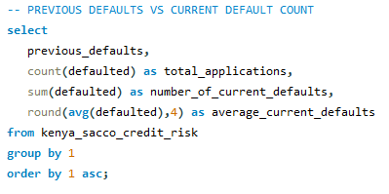
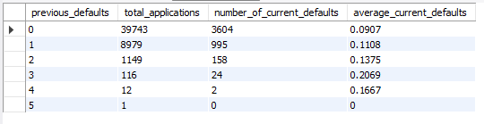
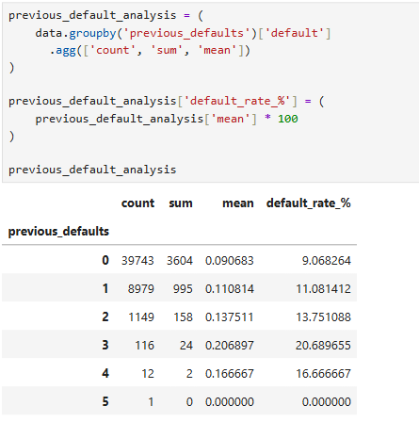

PREVIOUS LATE PAYMENTS VS CURRENT DEFAULT
-- Are borrowers with a history of late payments more likely to default?
-- Shows whether previous repayment behavior is associated with current default.
-- More previous late payments may be associated with higher default risk because they indicate a history of repayment difficulty.

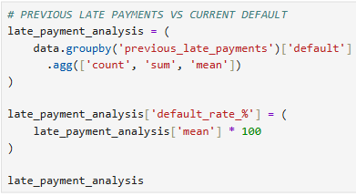
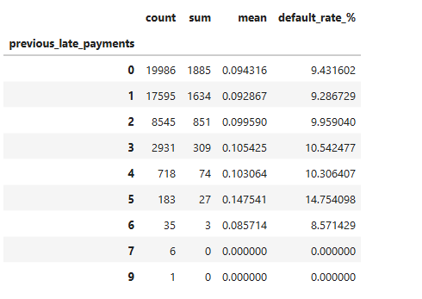
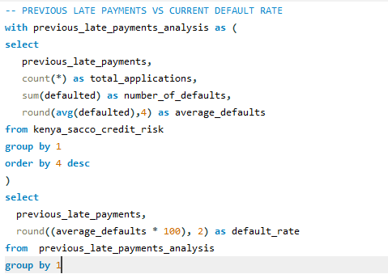
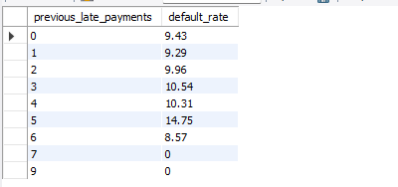

SAVINGS BALANCE VS DEFAULT
-- Do borrowers with more savings have lower default rates?
-- Examines whether financial reserves are associated with repayment performance.
-- Higher savings may be associated with lower default because borrowers have a financial buffer for unexpected expenses.
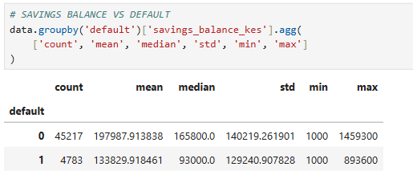
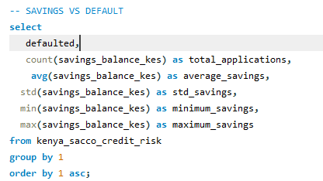
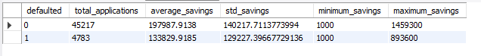

OTHER DEBT VS DEFAULT
-- Are borrowers with more existing debt more likely to default?
-- Shows whether existing financial obligations are associated with default.
-- Higher existing debt may increase repayment pressure and therefore be associated with higher default.
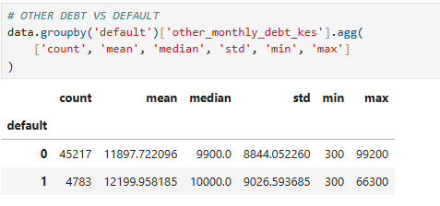
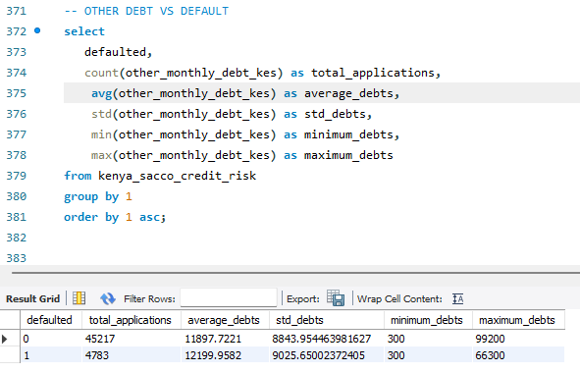

WHAT WE'VE ACCOMPLISHED
Variable | Relationship examined
Employment type | → Default
Loan product | → Default
County | → Default
Age | → Default
Monthly income | → Default
Loan amount | → Default
Savings | → Default
Other debt | → Default
Previous defaults | → Default
Previous late payments | → Default

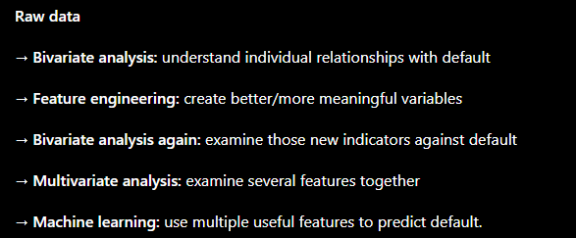

FEATURE ENGINEERING.
-- We are going to generate some features from numerical variables that will help in doing a better bivariate analysis with the default (target variable).
-- We'll focus first on the borrower's financial capacity.The key questions are:
- How large is the loan compared with income?
- How much existing debt does the borrower have relative to income?
- How much money is left after monthly cash inflows and outflows?
- How much of income is committed to loan repayment?
- How strong are the borrower's savings relative to income?
- Do these financial measures differ between defaulters and non-defaulters?

CREATE FINANCIAL RISK FEATURES
Loan-to-Income Ratio.
-- Business question: Are borrowers requesting relatively large loans compared with their income more likely to default?
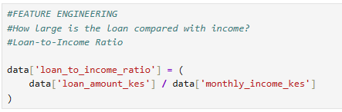
Debt-to-Income Ratio(DTI).
-- Business question: Are borrowers who already have higher debt obligations relative to their income more likely to default?
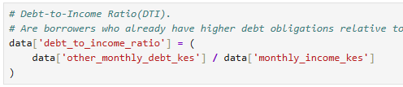

Total-Debt-to-Income Ratio
-- After taking this new loan, how much of the borrower's monthly income would be committed to debt payments?
-- This can be particularly useful for a SACCO/MFI because it considers both existing debt and the proposed loan.
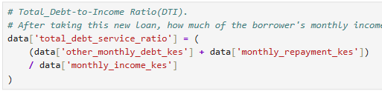
Monthly Cash Flow
-- Business question: Do borrowers with weaker monthly cash flow have higher observed default rates?
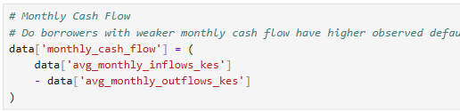
Cash-Flow-to-Income Ratio
-- Business question: Are borrowers who have a higher cash flow relative to their income more likely to default?
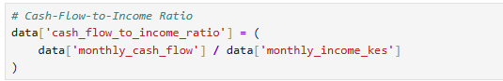

Repayment-to-Income Ratio
-- Business question: Does a larger monthly repayment relative to income correspond with higher observed default rates?
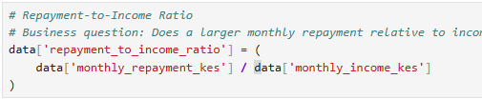

Savings-to-Income Ratio
-- Business question: Do borrowers with stronger savings relative to income have different observed default rates?
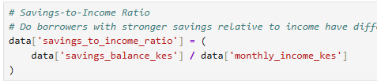

CHECK THE NEW FEATURES
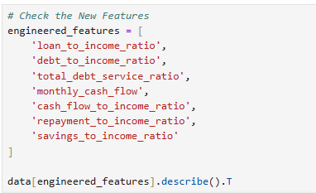
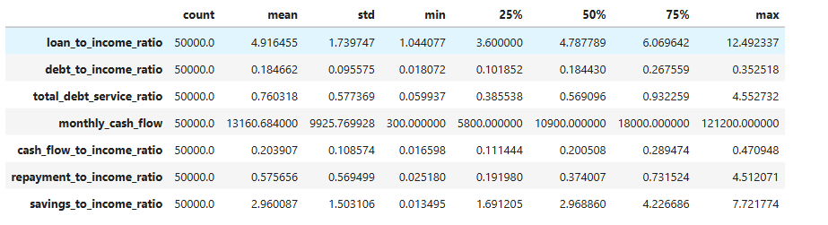

COMPARE THESE FEATURES WITH DEFAULT
-- Let's first compare the averages and medians:

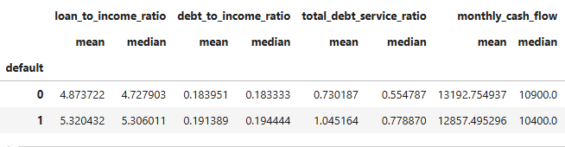
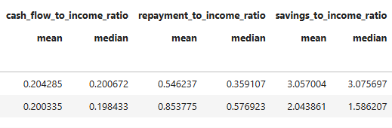
Loan-to-Income Ratio
-- Interpretation: Defaulted borrowers had higher loan-to-income ratios(5.32 Vs 4.87). -- Borrowers who defaulted generally requested loans that were larger relative to their monthly income.
Debt-to-Income Ratio
-- Defaulted borrowers have a slightly higher existing-debt-to-income ratio(19.4% median Vs 18.3%).Defaulted borrowers tended to have slightly more existing monthly debt relative to their income.
Total Debt-Service Ratio
-- Your results show:
- Non-default mean = 73.0%
- Default mean = 105.2%
- Non-default median = 55.5%
- Default median = 77.9%
-- That's a substantial difference.
-- interpretation: Defaulted borrowers had substantially higher total debt-service ratios, indicating that their combined existing and proposed debt obligations represented a larger proportion of their income.
-- This is exactly the kind of engineered feature that can provide information that wasn't as obvious from looking at the original columns individually.
Monthly Cash Flow
-- Here the difference is much smaller.
-- the median is: Default: KES 10,400, Non-default: KES 10,900
-- the mean is: Default: KES 12,857, Non-default: 13,192
-- Interpretation: Defaulted borrowers had slightly lower monthly cash flow than non-defaulted borrowers.
Cash_flow_to_income_ratio
-- Here the difference is very small.
-- the median is: Default: 19.84%, Non-default: 20.07%
-- the mean is: Default: 20.03%, Non-default: 20.42%
-- Interpretation: Defaulted borrowers had slightly lower cash_flow_to_income_ratio than non-defaulted borrowers. Borrowers who have a slightly lower cash flow relative to their income are more likely to default but the difference between the two groups is small in this dataset.
Repayment-to-Income Ratio
-- The results show:
- Non-default mean = 54.46%
- Default mean = 85.38%
- Non-default median = 35.91%
- Default median = 57.69%
-- That's a substantial difference.
-- Interpretation: Borrowers with a larger monthly repayments relative to income are very likely to default.
-- This makes business sense as a risk indicator: a larger repayment relative to income represents greater repayment pressure.
Savings-to-Income Ratio
-- The results show:
- Non-default mean = 305.7%
- Default mean = 204.4%
- Non-default median = 307.6%
- Default median = 158.6%
-- That's a substantial difference.
-- Business question: Borrowers with lower savings relative to income are very likely to default.

Let's put all 7 engineered features together

Feature | Default vs non-default | Initial signal
Loan-to-income | 5.32 vs 4.87 | Higher among defaults
Debt-to-income | 19.1% vs 18.4% | Slightly higher among defaults
Total debt-service | 105.2% vs 73.0% | Much higher among defaults
Monthly cash flow | KES 12,858 vs KES 13,193 | Slightly lower among defaults
Cash-flow-to-income | 20.03% vs 20.42% | Very similar
Repayment-to-income | 85.38% vs 54.46% | Much higher among defaults
Savings-to-income | 204.4% vs 305.7% | Much lower among defaults

The three that stand out most
-- Total debt-service ratio: Higher among defaults.
-- Repayment-to-income ratio: Higher among defaults.
-- Savings-to-income ratio: Lower among defaults

BIVARIATE ANALYSIS ACROSS LEVELS, NOT JUST ON AVERAGES AND MEDIAN
-- So far, our bivariate analysis has been Comparing means and medians, telling us: Are the two groups(default and non-default) different on average?
-- Now we're moving beyond comparing averages and actually seeing how default rates behave across levels of repayment burden.
-- But for credit risk, we want a more useful question: Does the default rate change as financial pressure increases?
-- For example, instead of simply saying: "Defaulted borrowers have a higher repayment-to-income ratio."we want to investigate: "What is the observed default rate among borrowers with repayment-to-income below 30%, 30–50%, 50–70%, 70–100%, etc.?"
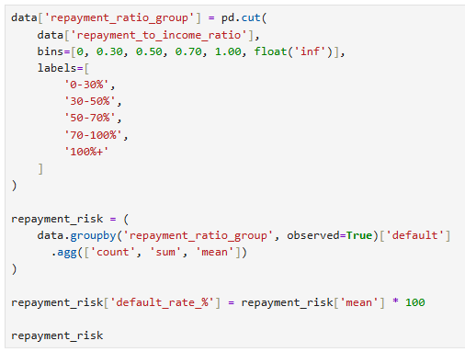
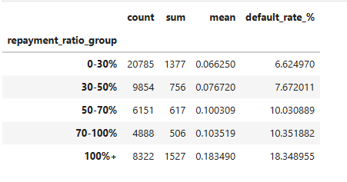
-- The overall dataset default rate was about 9.57%, so these groups show a meaningful pattern around that baseline.
-- INTERPRETATION: As the monthly repayment becomes larger relative to income, the observed default rate generally increases.
-- The 100%+ group is particularly notable: Borrowers whose proposed monthly repayment exceeds their monthly income had an observed default rate of 18.35%, compared with 6.62% among borrowers whose repayment was below 30% of income.
-- Repayment burden analysis indicates that observed default rates generally increase as proposed monthly loan repayments become larger relative to borrower income. The highest-risk group in this analysis was borrowers with repayment-to-income ratios above 100%, who recorded an 18.35% default rate compared with 6.62% for borrowers below 30%. This suggests that repayment burden may be an informative feature for credit-risk assessment.

Total debt-service ratio: Higher among defaults.
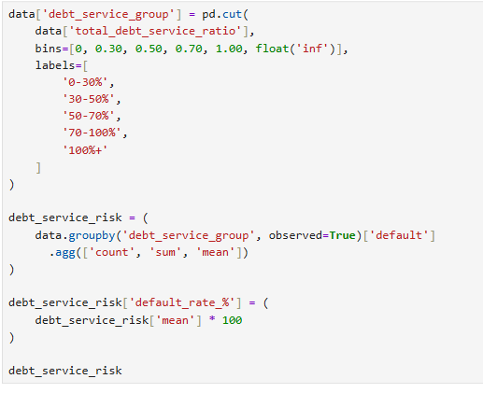
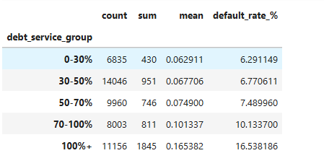

-- The pattern: As total debt obligations become larger relative to income, the observed default rate generally increases.
-- Borrowers in the 100%+ category have an observed default rate of 16.54% compared 6.29% for the 0–30% group.
-- So the observed default rate is substantially higher among borrowers whose combined debt obligations exceed their monthly income.
-- Total debt-service analysis shows that observed default rates generally increase as debt obligations become larger relative to monthly income. Borrowers with total debt-service ratios above 100% recorded a 16.54% default rate, compared with 6.29% among borrowers in the 0–30% category. This indicates that total debt-service ratio may be an informative feature for credit-risk modeling.

Savings-to-income ratio
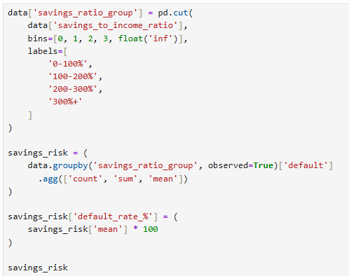
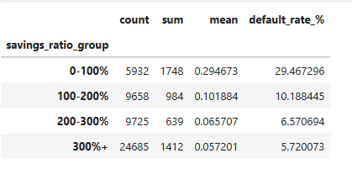

-- There is a very clear inverse relationship: As savings relative to income increases, the observed default rate generally decreases.
-- Borrowers with savings below 100% of monthly income have the highest default rate of 29.47% default rate.
-- Borrowers with savings above 300% of monthly income have the lowest default rate of 5.72% default rate.
-- Borrowers with lower savings relative to monthly income had substantially higher observed default rates. The default rate was 29.47% among borrowers whose savings were below 100% of monthly income, compared with 5.72% among borrowers whose savings exceeded 300% of monthly income. This suggests that savings relative to income may be an informative indicator of financial resilience in credit-risk modeling.

